In summary, model training for autonomous walking involves iteratively improving a deep reinforcement learning model using a structured and diverse training environment, leveraging feedback through rewards to refine the AI's walking policy. This process transforms raw sensor data and trial-and-error experiences into a robust, adaptable walking ability for the AI.

**3.4 Feature Extraction**

Feature extraction is a crucial step in developing AI systems that autonomously learn to walk, as it involves identifying and isolating the most relevant data from the robot's sensors to inform the learning algorithm. This process transforms raw sensor data into meaningful features that capture the essential aspects of the robot's state and environment, enabling the AI to make informed decisions.

Initially, raw data from various sensors, including accelerometers, gyroscopes, and cameras, is collected. This data contains detailed information about the robot’s movements, forces exerted, and environmental interactions. However, raw data alone is often too complex and voluminous for effective processing. Feature extraction simplifies this data by focusing on key attributes that influence walking behavior.

One common approach is to extract kinematic features such as joint angles, velocities, and accelerations. These features provide insights into the robot’s posture and dynamics, which are critical for maintaining balance and executing coordinated movements. Additionally, dynamic features like ground reaction forces and torque can be extracted to understand the physical interactions between the robot and its environment.

Another important aspect of feature extraction involves temporal features, which capture changes over time. This can include the sequence of joint movements or the progression of forces during each step. Temporal features help the AI recognize patterns and predict future states, improving its ability to plan and adjust movements in real-time.

Sensor fusion techniques are also employed to combine data from multiple sensors, enhancing the robustness and accuracy of the extracted features. For instance, combining visual data from cameras with proprioceptive data from joint sensors can provide a comprehensive view of the robot’s surroundings and its own state.

Feature extraction also involves dimensionality reduction techniques such as Principal Component Analysis (PCA) to reduce the complexity of the data while retaining the most important information. This step is essential for speeding up the learning process and preventing the algorithm from becoming overwhelmed by irrelevant details.

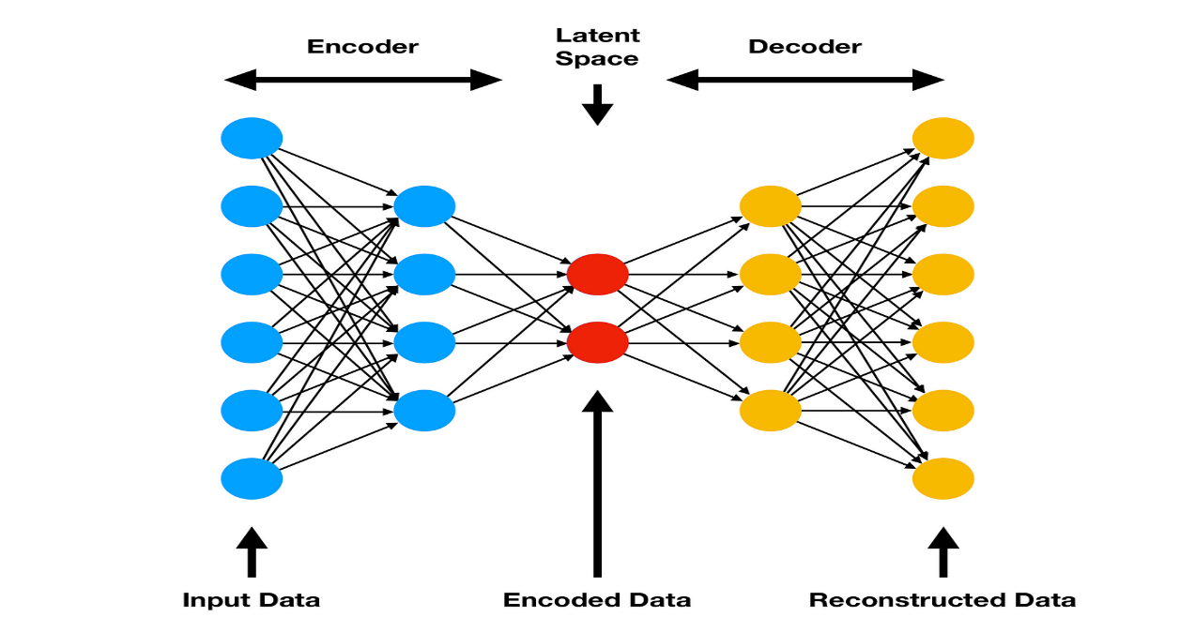By focusing on these key features, the AI system can effectively learn the complex task of walking. The extracted features serve as the input to the reinforcement learning algorithm, guiding the robot's actions and adaptations in various environments. This process not only improves the efficiency of the learning algorithm but also enhances the robot's overall performance, enabling it to walk autonomously with greater stability and adaptability.

**Figure 2.1: Feature Extraction**